

**LAB #13: Dynamic Routing Protocols**

**EE-432L Computer Networks**

**Submitted to:**

Mr. Azeem Iqbal

**Submitted by:**

2021-EE-351

2021-EE-355

**Section A**

**Session 2021**

**7th Semester, Fall 2024**

**Department of Electrical, Electronics & Telecommunication**

**Engineering UET Lahore (Faisalabad Campus)**

Dynamic Routing Protocols

Objective:

To analyze and compare 17 dynamic routing protocols for efficient data packet transmission across networks, focusing on their algorithms, performance metrics, and adaptability. This study aims to identify optimal protocols for diverse network scenarios

Lab Topology:

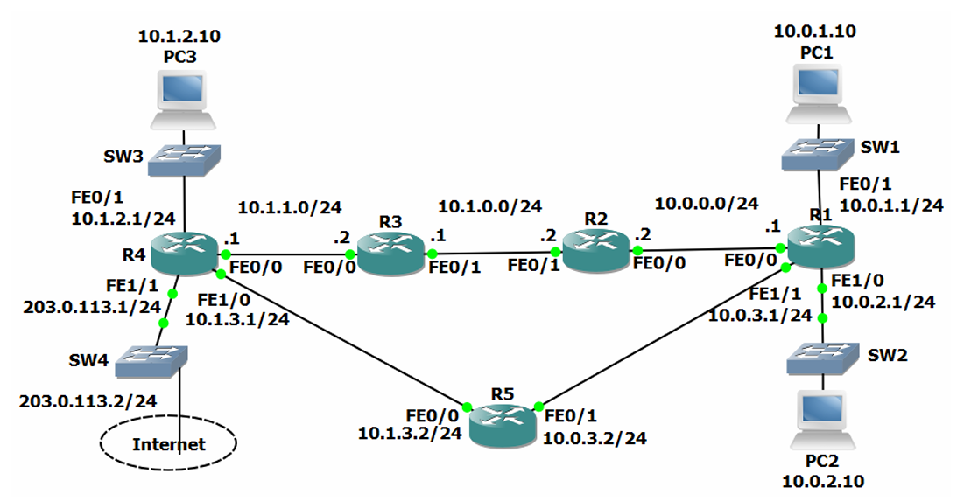

# Routing Protocol Updates

1. Enter the commands below on each router to provision a basic RIPv1 configuration and enable RIP on every interface.

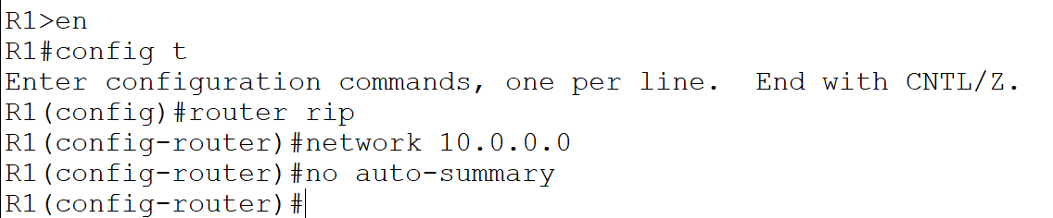

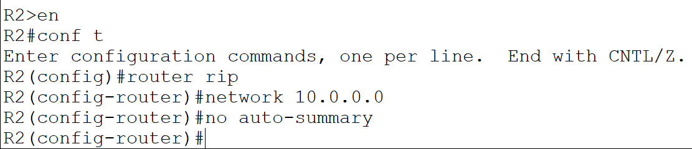

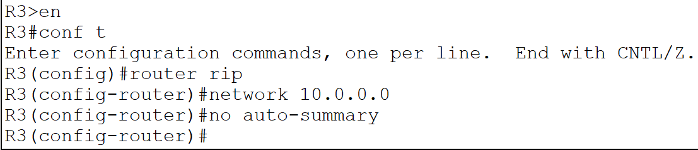

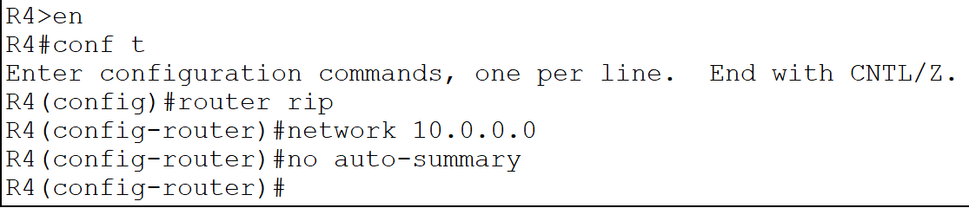

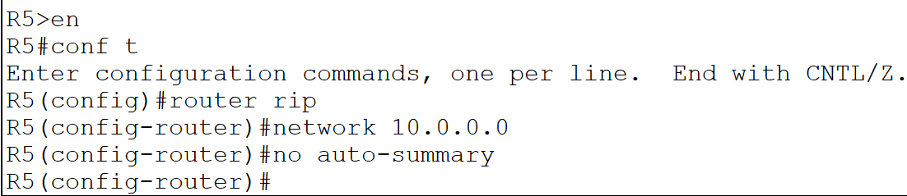

1. Debug the routing protocol updates on R1 with the ‘debug ip rip’ command. Observe the updates being sent and received. What kind of traffic is used (unicast, broadcast or multicast)?

The updates are being sent on the broadcast address 255.255.255.255. All hosts on the subnet must process the packets.

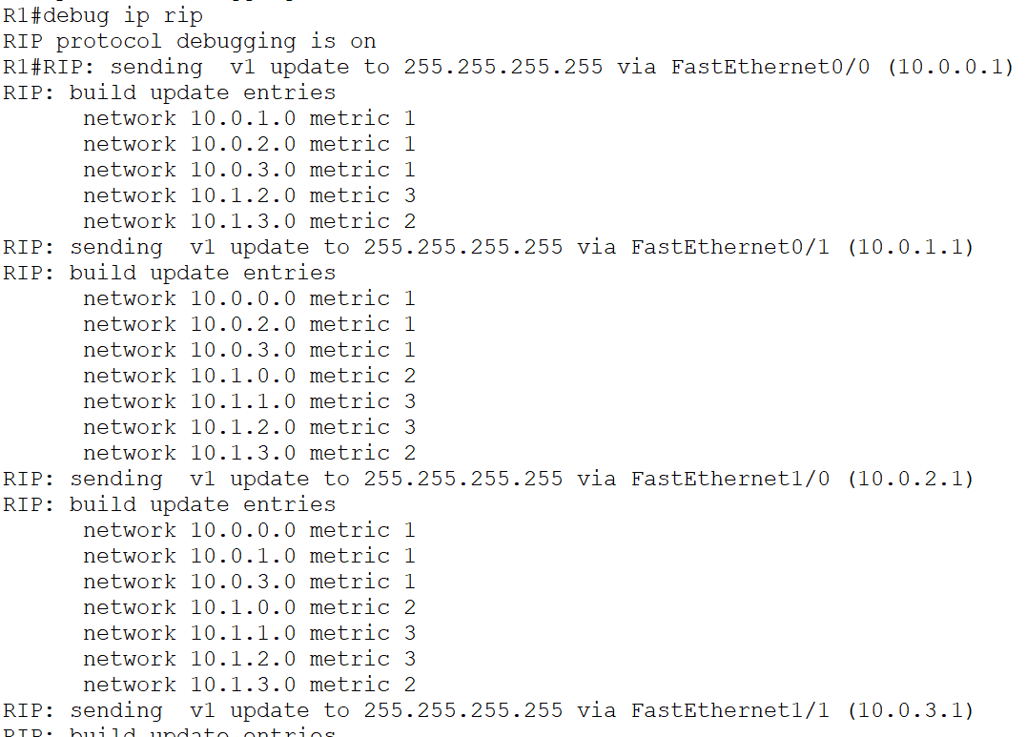

1. Enter the commands below to enable RIPv2 on every router.

router rip version 2

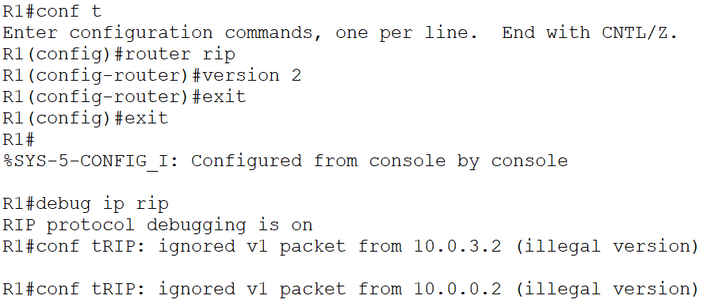

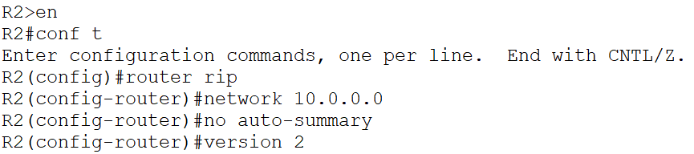

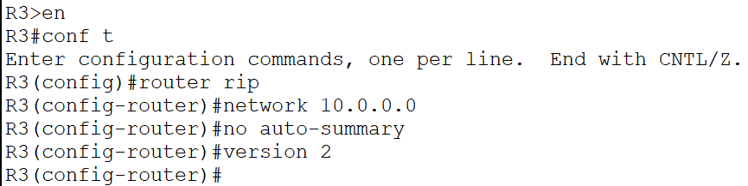

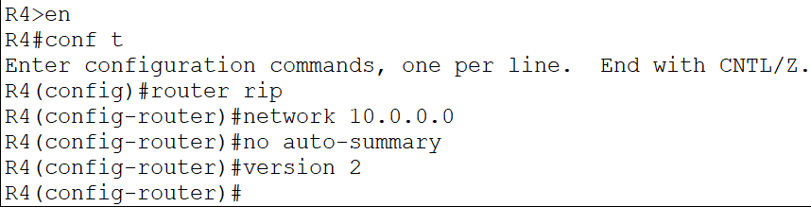

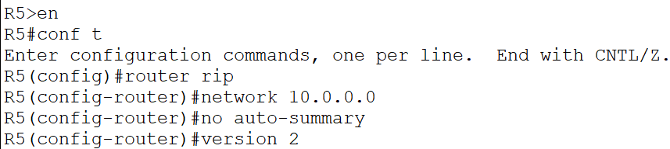

1. What kind of traffic is used for the updates now?

The updates are being sent on the RIPv2 multicast address 224.0.0.9. Only RIPv2 routers will process the packets beyond layer 3.

RIP: sending v2 update to **224.0.0.9** via FastEthernet1/0 (10.0.2.1)

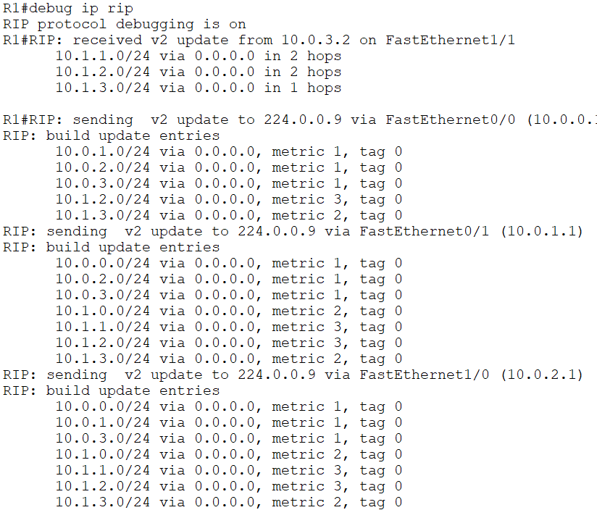

1. Turn off all debugging on R1.

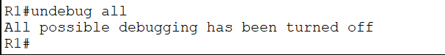

1. Check that RIP routes have been added to R1 and it has a route to every subnet in the lab.

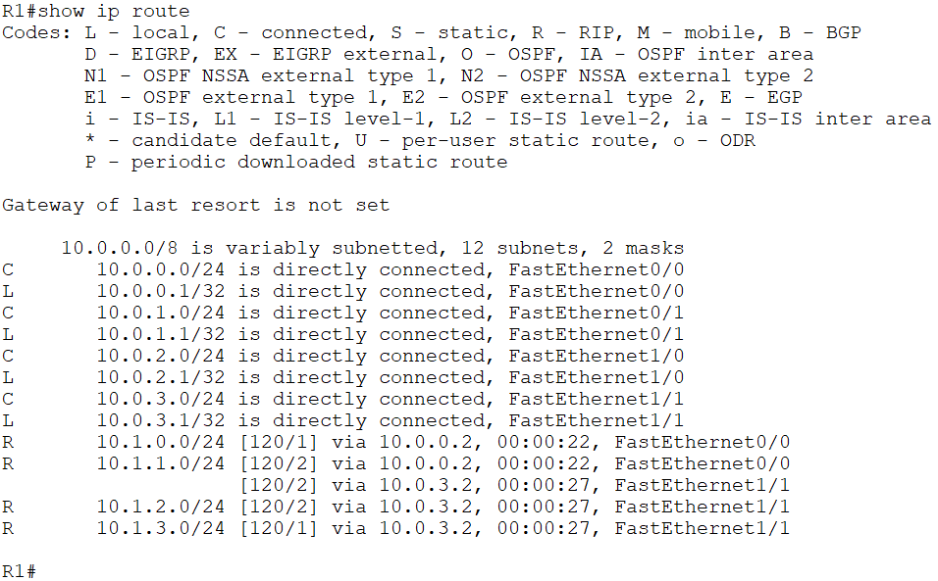

1. Why are there two routes to the 10.1.1.0/24 network in the routing table?

Two paths to 10.1.1.0/24 have an equal metric – a hop count of 2. Both routes are installed in the routing table and the router will perform Equal Cost Load Balancing between the next hops of 10.0.3.2 and 10.0.0.2.

# Comparing Routing Protocols

1. View the RIP database on R1.

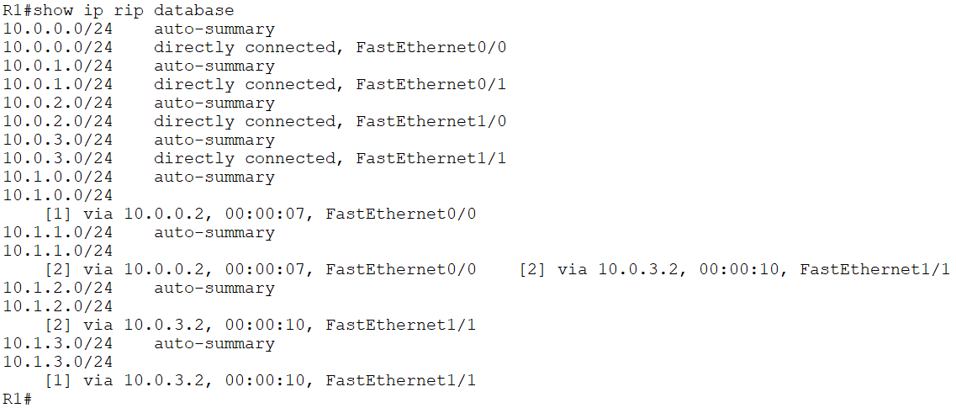

1. Enter the commands below on each router to provision a basic OSPF configuration and enable OSPF on every interface.

router ospf 1

network 10.0.0.0 0.255.255.255 area 0

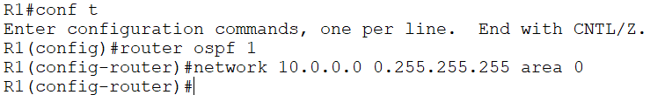

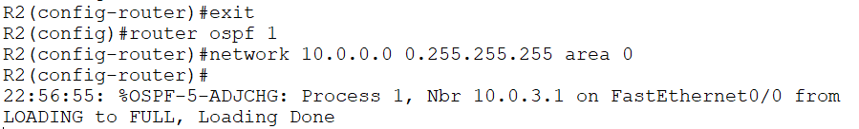

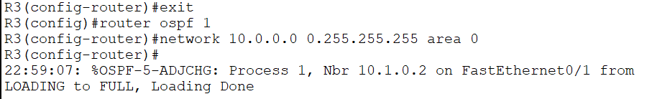

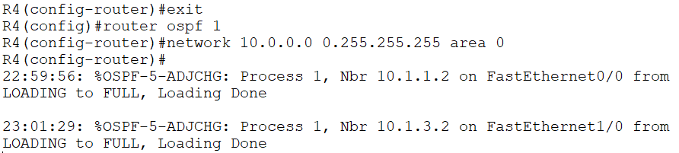

1. Give OSPF time to converge. Are RIP routes included in the routing table on R1 now? Why or why not?

The RIP routes are replaced by OSPF because its Administrative Distance of 110 is preferred to RIP’s AD of 120.

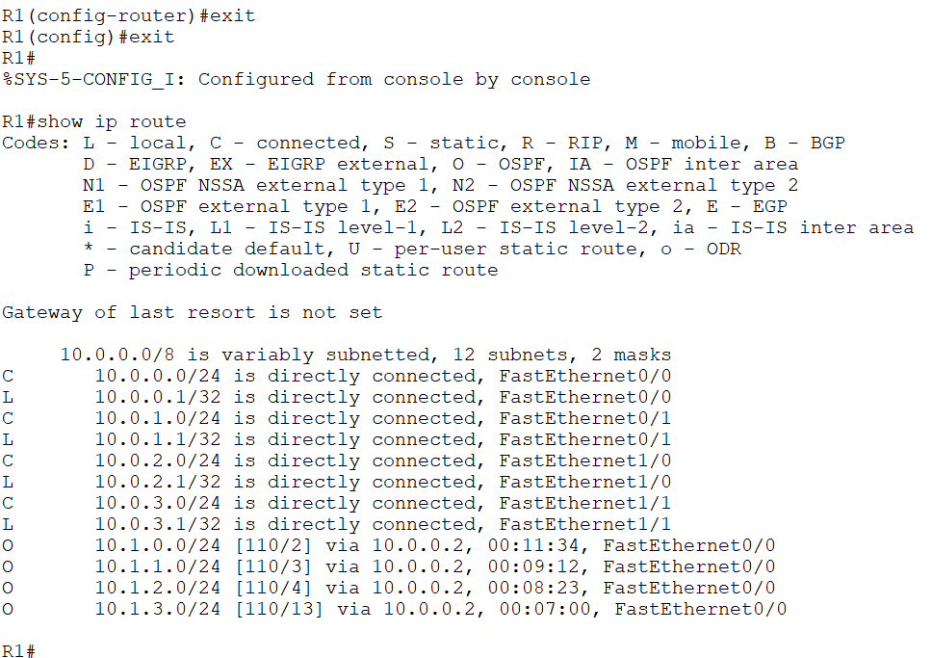

1. Why is there now only one route to the 10.1.1.0/24 network?

OSPF uses cost as its metric which takes into account interface bandwidth. The interfaces on R5 have a configured bandwidth of 10Mbps. The interfaces along the top path of the network topology all have the default FastEthernet bandwidth of 100Mbps so this route is preferred. All traffic will go via the next hop 10.0.0.2.

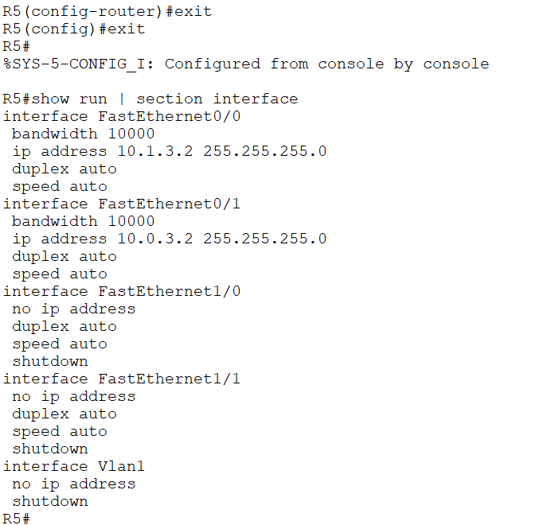

1. Disable interface FastEthernet 0/0 on R2. What do you expect to happen to R1’s routing table?

OSPF will reconverge. The routes to the 10.1.0.0 networks via R2 will be removed from the routing table and replaced with routes via R5.

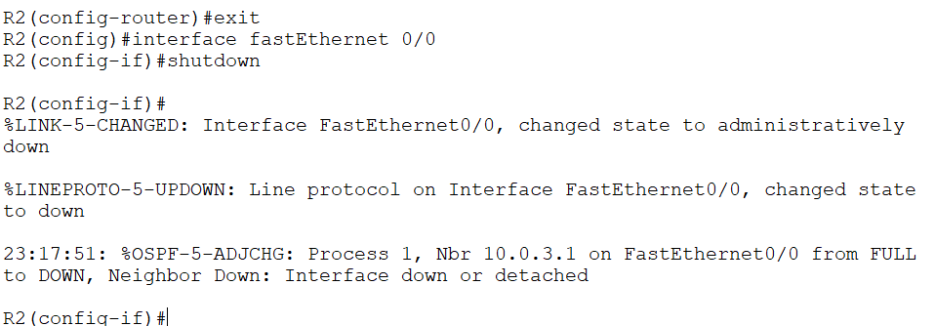

1. Verify your expected changes to R1’s routing table.

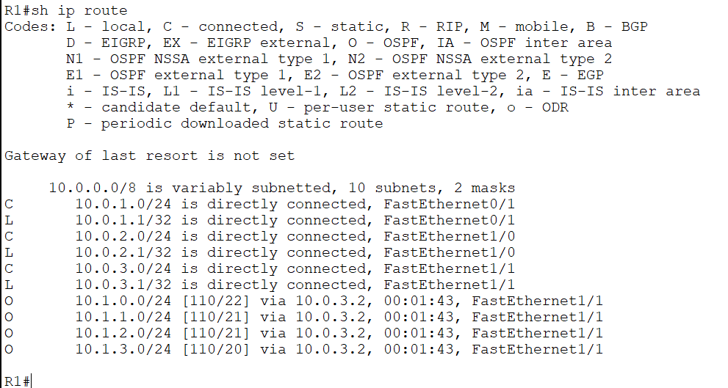

1. Aside from the next hop address, what else has changed on the routing table?

The new routes have a higher metric. This is why they were not in the routing table when the path via R2 was up.

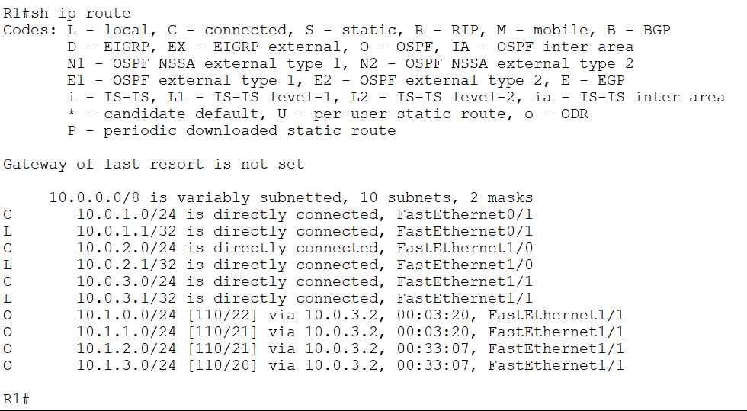

1. View the OSPF database on R1 with the ‘show ip ospf database’ command. What is different between it and the RIP database? Why?

RIP is a Distance Vector routing protocol so it only knows its directly connected neighbors and the lists of networks those neighbors have advertised.

OSPF is a Link State routing protocol so it knows the state of every link on every router in its area.

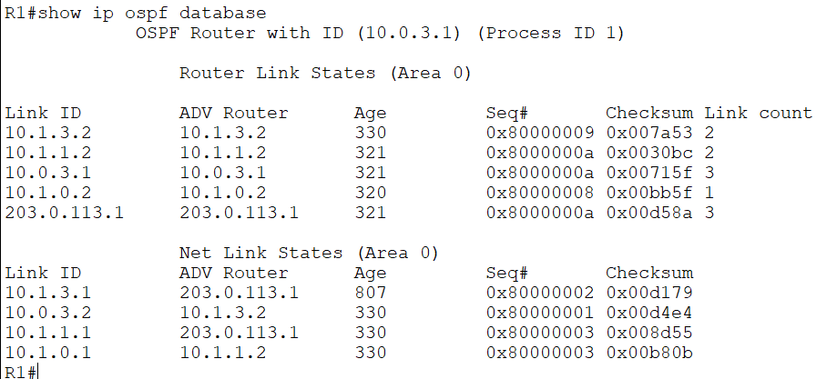

# Routing Protocol Metrics and Administrative Distance

1. Enter the command below to remove OSPF on every router

no router ospf 1

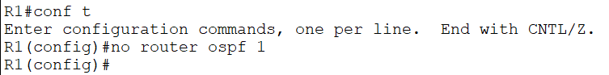

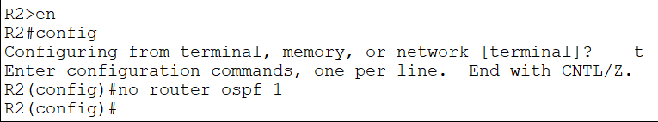

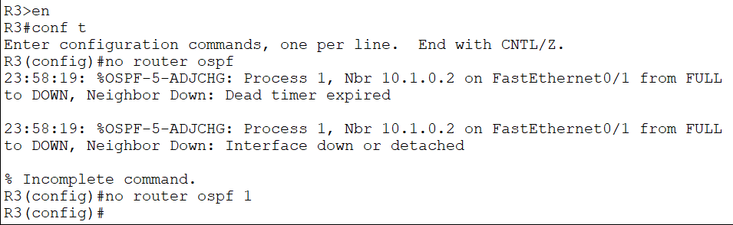

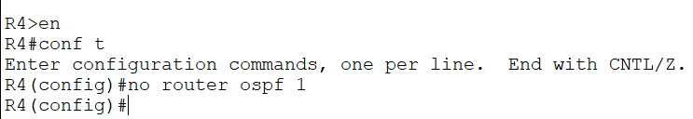

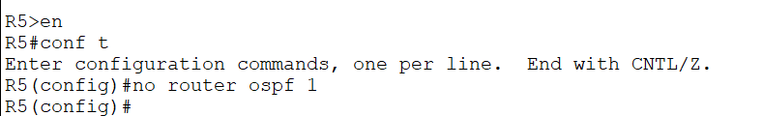

1. Will R1 still have connectivity to R4?

Yes. RIP is still running so RIP routes will replace the removed OSPF routes in the routing table.

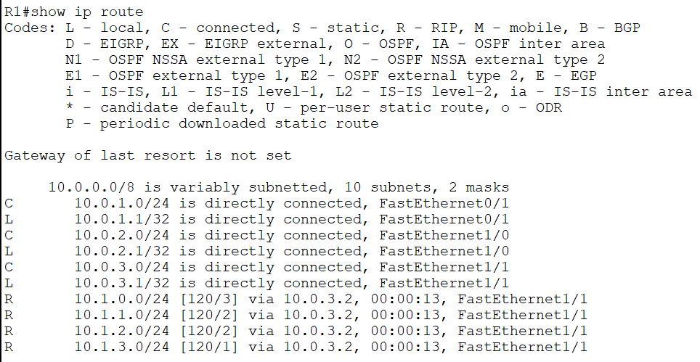

1. What is the metric to the 10.1.1.0/24 network on R1?

A hop count of 2.

1. Why is there only one route on R1 to the 10.1.1.0/24 network now?

Interface FastEthernet 0/0 on R2 is still shut down so no routes go through it.

1. Make the required change so that there are two routes to the 10.1.1.0/24 network in the routing table on R1.

R2(config)#interface f0/0 R2(config-if)#no shut

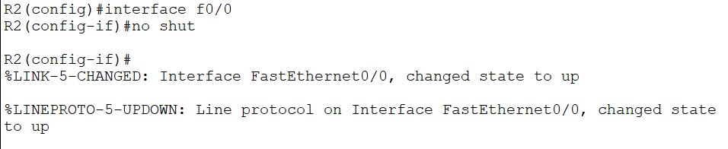

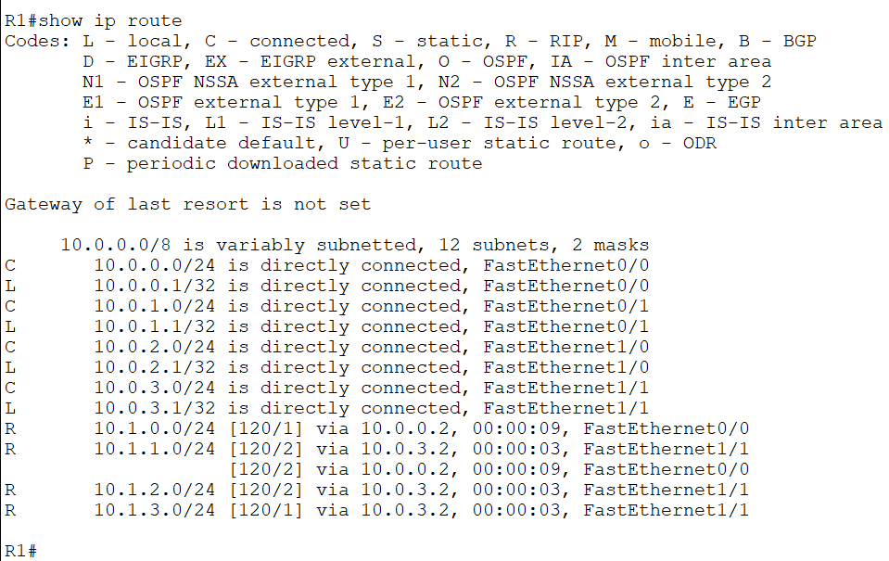

1. Enter the commands below on each router to provision a basic EIGRP configuration and enable EIGRP on every interface.

router eigrp 100 no auto-summary

network 10.0.0.0 0.255.255.255

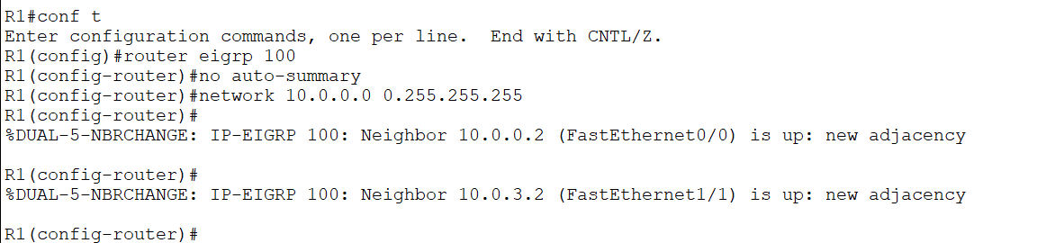

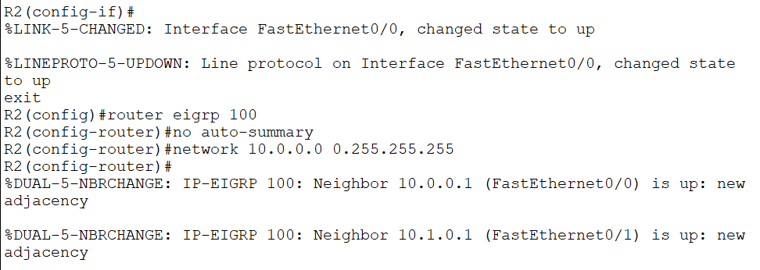

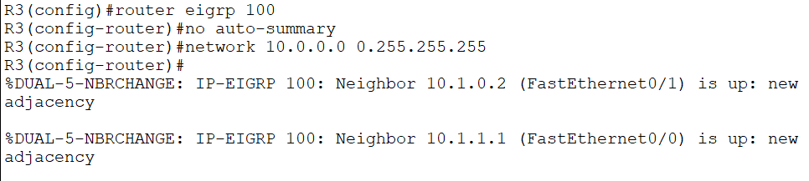

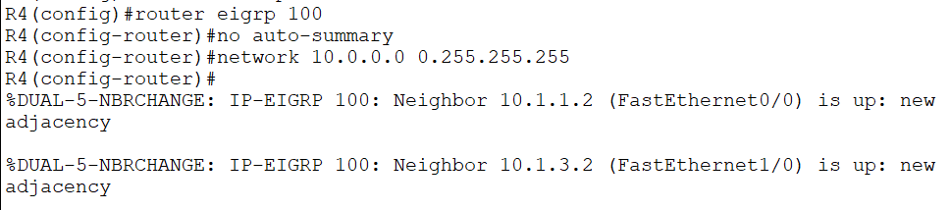

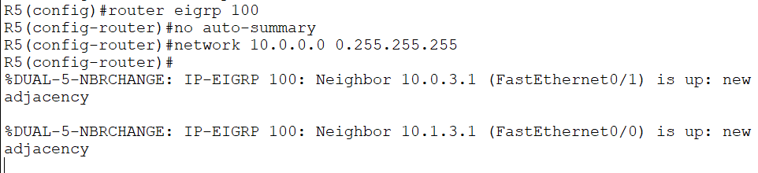

1. What changes do you expect to see in the routing tables? Why?

The RIP routes will be replaced by EIGRP because its Administrative Distance of 90 is preferred to RIP’s AD of 120.











1. Verify the changes to the routing table on R1.

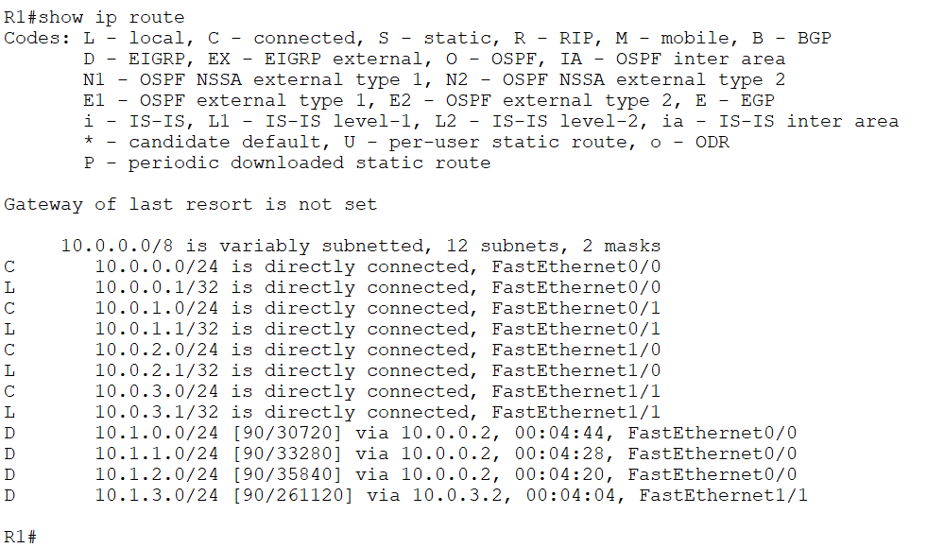

1. What is the metric to the 10.1.1.0/24 network on R1?

A composite metric of 33280.

1. Why is there only one route to the 10.1.1.0/24 network on R1?

EIGRP uses a composite metric which takes into account interface bandwidth and delay. The interfaces on R5 have a configured bandwidth of 10Mbps. The interfaces along the top path of the network topology all have the default FastEthernet bandwidth of 100Mbps so this route is preferred. All traffic will go via the next hop 10.0.0.2.

1. Disable RIP and EIGRP on R5 with the commands below.

R5(config)#no router rip R5(config)#no router eigrp 100

1. Configure the network so that there is still connectivity between all subnets if the link between R1 and R2 goes down. Accomplish this with six commands. Do not enable EIGRP on R5 but note that the routing protocol is expected to be enabled there in the future.

Floating static routes need to be added as a backup to the EIGRP routes. We want to ensure EIGRP routes are preferred when available so set the AD to be higher than EIGRP’s AD of 90.

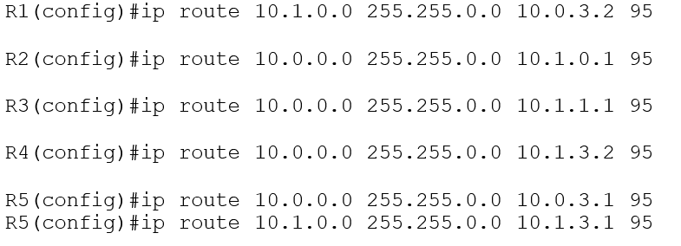

R5 is not running EIGRP so it is not currently necessary to set the Administrative Distance for its routes to 95. It is required to prevent the floating static routes from being preferred when EIGRP is enabled in the future however.

Summary routes need to be used to accomplish the task in six commands.

1. What changes do you expect to see to the routing table on R1?

The summary route will be added to the routing table but not used because it has a prefix length of /16, compared to the EIGRP routes which have a longer prefix length of /24.

If individual floating static routes had been added for each of the /24 destination networks then these would not have appeared in the routing table (unless a link went down) because EIGRP has a better Administrative Distance.

1. Verify the changes to the routing table on R1.

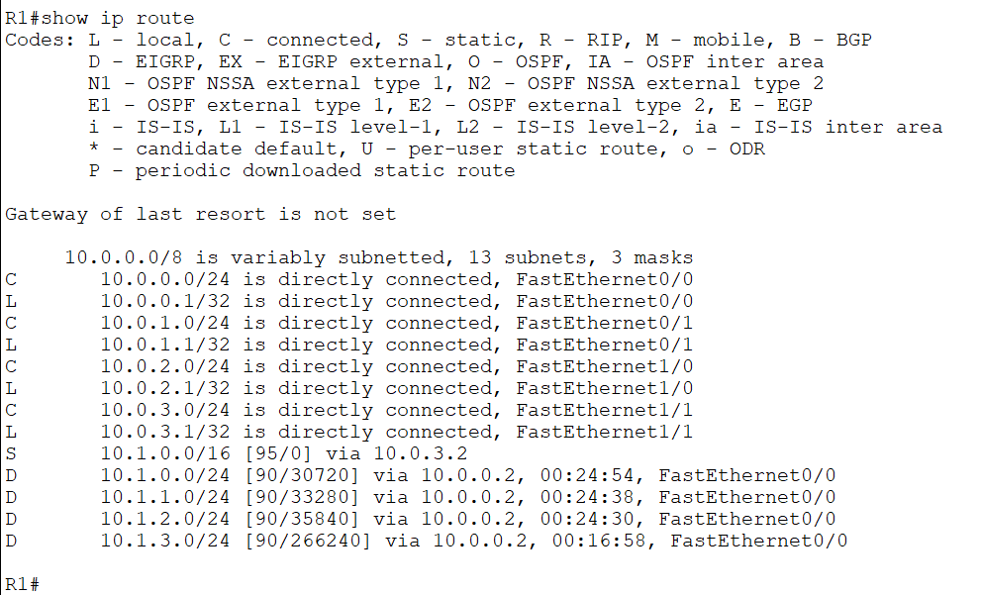

1. Verify that traffic from PC1 to PC3 still goes via R2.

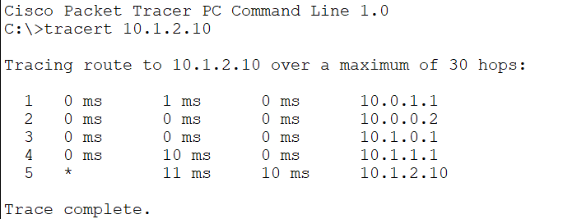

1. Shut down interface FastEthernet 0/0 on R2.

R2(config)#interface f0/0 R2(config-if)#shutdown

1. What changes do you expect to see on R1’s routing table?

The EIGRP routes will be removed.

1. Verify the changes to the routing table on R1.

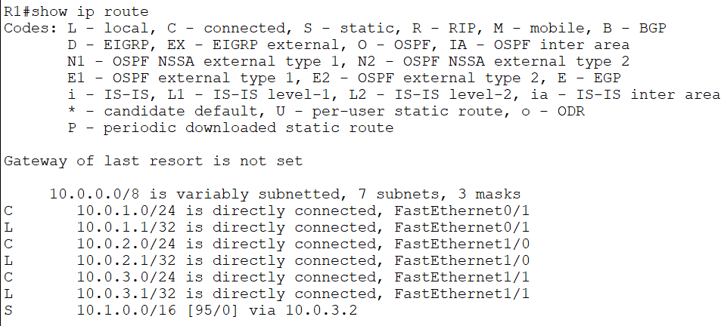

1. Verify connectivity between PC1 and PC3.

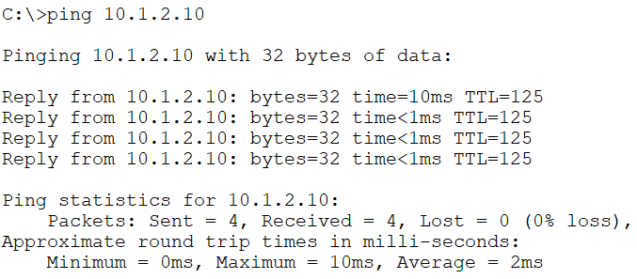

1. Verify the traffic goes via R5.

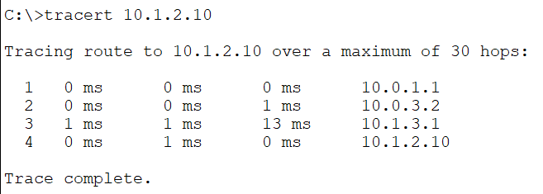

1. Bring interface FastEthernet 0/0 on R2 back up.

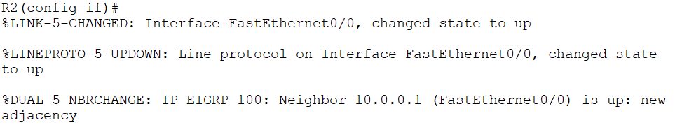

1. Enter the commands below on R5 to provision a basic EIGRP configuration and enable EIGRP on every interface.

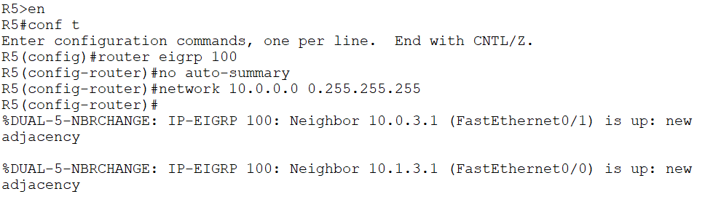

# Loopback Interfaces

1. Configure loopback interface 0 on each router. Assign the IP address192.168.0.x/32, where ‘x’ is the router number (for example 192.168.0.3/32 on R3.)

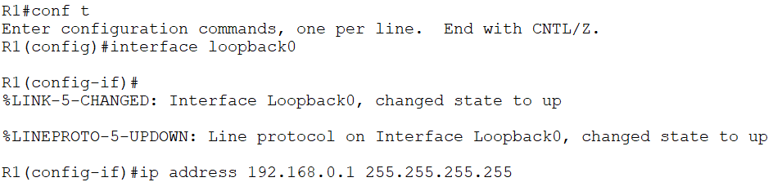

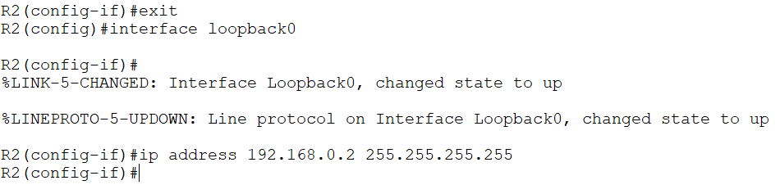

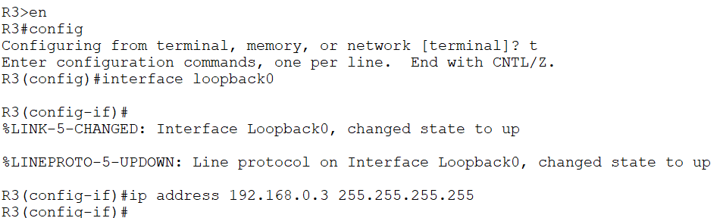

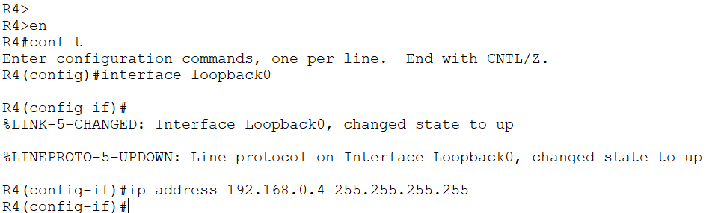

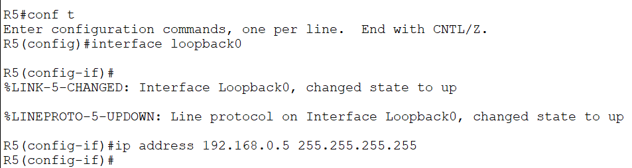

1. Is there connectivity to the loopback interfaces from the PCs? Why or why not?

There is no connectivity from the PCs to the loopback interfaces because they are not in the routing tables of the routers (apart from the local loopback interface on each router). The loopback interfaces are not in the routing tables because they are in the 192.168.0.0/24 range which has not been included in the routing protocol.

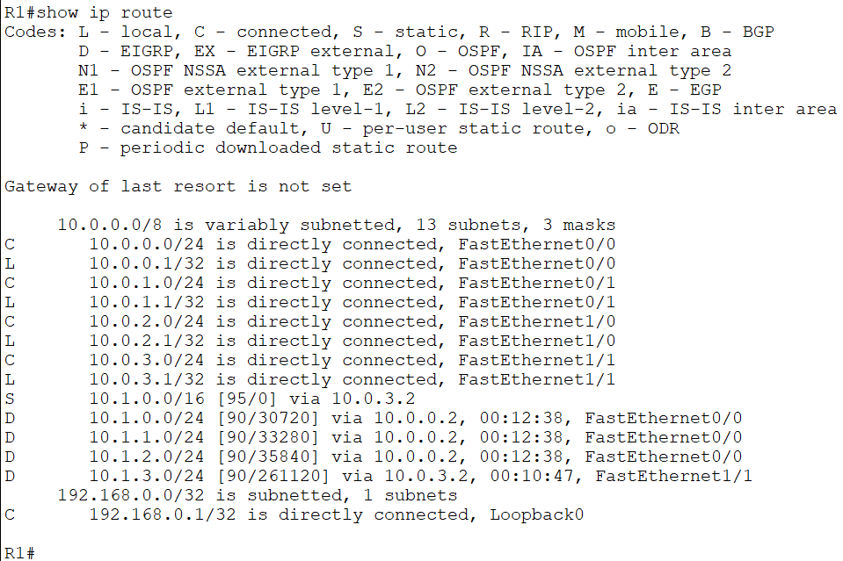

1. Enter the commands below on each router to include the loopback interfaces in EIGRP.

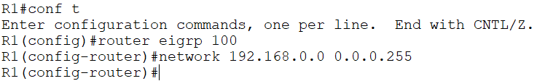

1. Verify the loopback interfaces are in the routing table on R1.

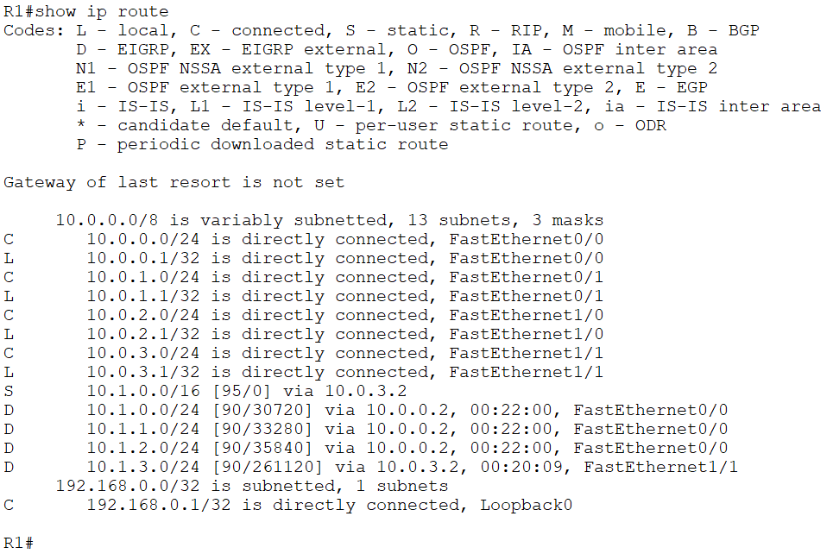

1. Verify connectivity from PC1 to the loopback interface on R5.

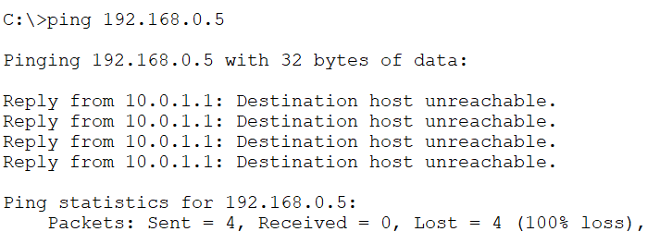

# Adjacencies and Passive Interfaces

1. Enter the command below to verify that R1 has established EIGRP adjacencies with R2 and R5.

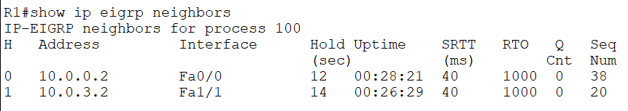

1. Verify that traffic from R5 to the directly connected interfaces on R1 goes via the FastEthernet 0/1 interface.

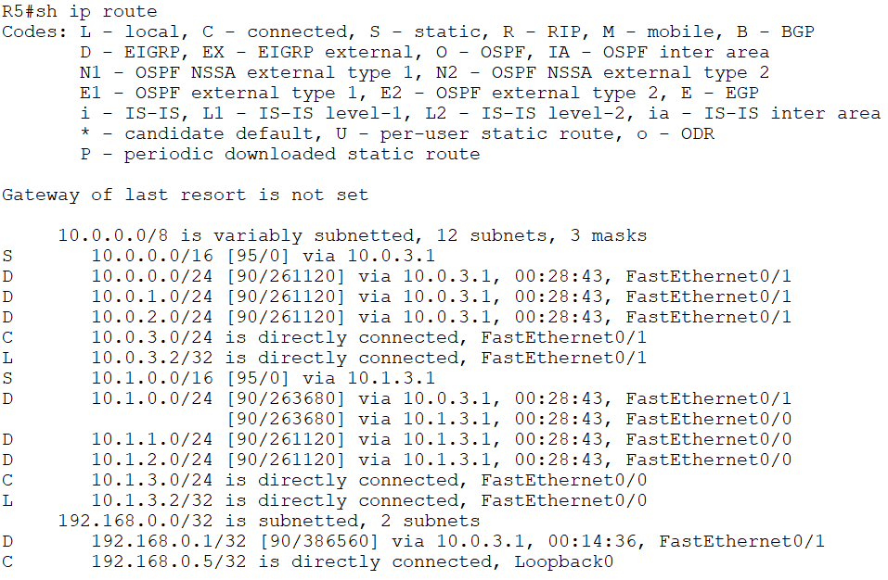

1. Enter the commands below to configure the loopback interface and the link to R5 as passive interfaces on R1.

R1(config-if)#router eigrp 100

R1(config-router)#passive-interface loopback0 R1(config-router)#passive-interface fastethernet1/1

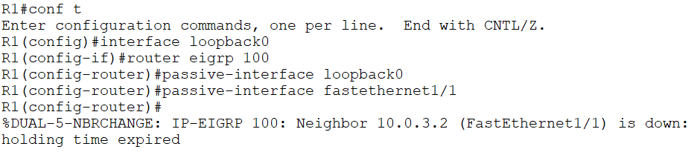

1. What changes do you expect to see in the routing table on R5 and why?



The EIGRP adjacency between R1 and R5 will go down. All EIGRP routes via R1 will be removed from the routing table and replaced with routes via R4.

Configuring the loopback interface as a passive interface on R1 does not affect any routing tables but is a best practice.

1. Verify the expected changes to the routing table on R5.

